OUR ŽAROŠICE – RECORDING IMAGE, SOUND, VIDEO PROCESSING

Žarošice elementary school and kindergarten,
Hodonín district,
funded organisation
696 34 Žarošice 321

Content:
Project information 3
Project description 3
Age determination 3
What skills should students master before starting the project? 3
What skills will the students learn as part of the project? 3
Technical equipment needed to implement the project 4
Financial complexity of the project 7
Movie script 8
Getting to know the technique 9
First flight tests 10
Exteriors 11
Video editing 12
Conclusion 13

Project information

Project description
The project is focused on the creation of an audiovisual work by the students themselves. Their task was to come up with a topic for joint work, to design and fine-tune the script, to learn how to control the necessary technology, to plan the progress of the individual activities so that at the end of the measured period they could present their short film.

Age determination
Eighth grade elementary school students were selected to work on the project. The reason was their relative maturity for working with relatively expensive equipment, some of them already had previous experience with video shooting. It was not possible to accept older pupils with regard to their preparation for entrance exams to secondary schools, as this was a relatively large-scale activity that took place entirely in their free time.

What skills should students master before starting the project?
Selected students are expected to have at least minimal experience with shooting video on a mobile phone due to image selection and lighting conditions. Furthermore, previous experience working with video editing is suitable, but it is not necessary to master any specific program.

What skills will the students learn as part of the project?
In the project, students will learn to use a camera with a tripod correctly, use the options provided by the tripod's fluid head, choose different angles of view of the object, control and distinguish shots at the level of detail - semi-detail - whole. They will learn to take into account the light conditions of the environment. They will master the drone, learn how to coordinate their hands so that they can maintain the direction. They will choose objects suitable for the presentation of the village, the continuity of individual images in logical contexts. When working with the Movie Studio 18 program, they select suitable shots, edit and assemble the whole.
At the same time as professional work, they will acquire the skill of working in a team, planning and dividing roles and tasks, and deepening personal responsibility for the assigned part of the task.

Technical equipment needed to implement the project
DJI MAVIC AIR 2 drone
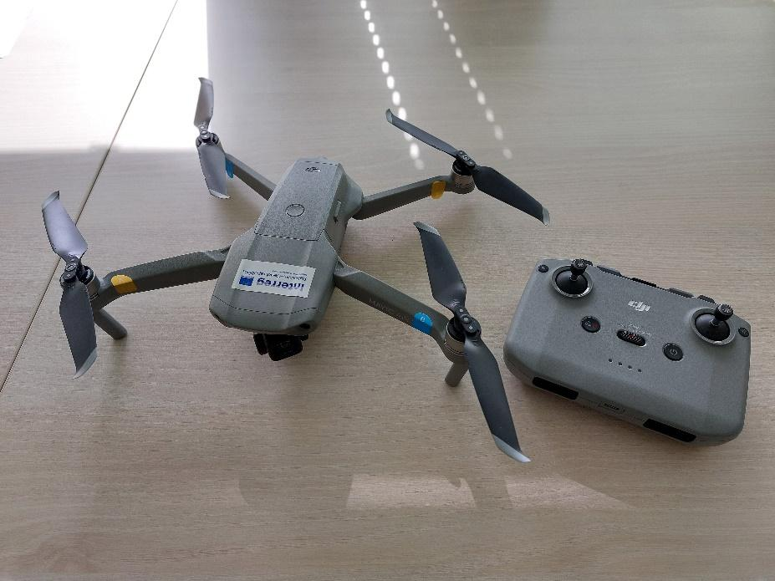

Video camera
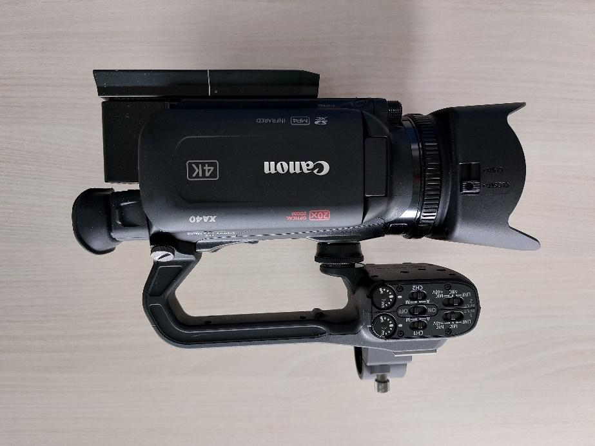

Microphone

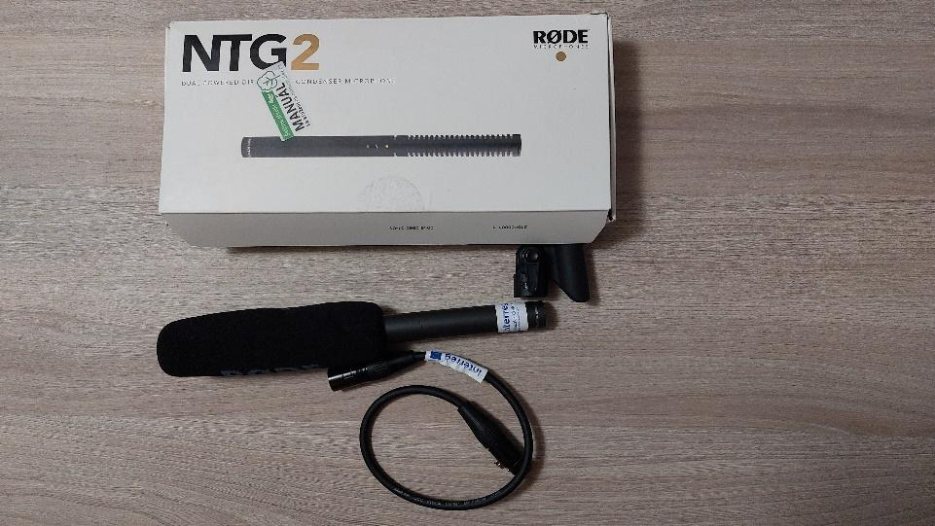

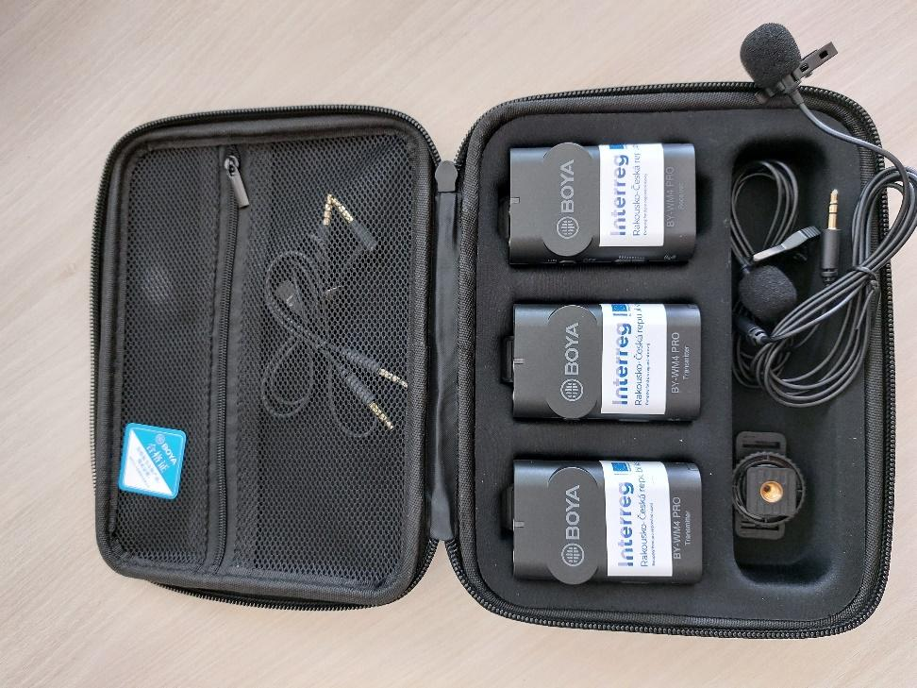

Tripod
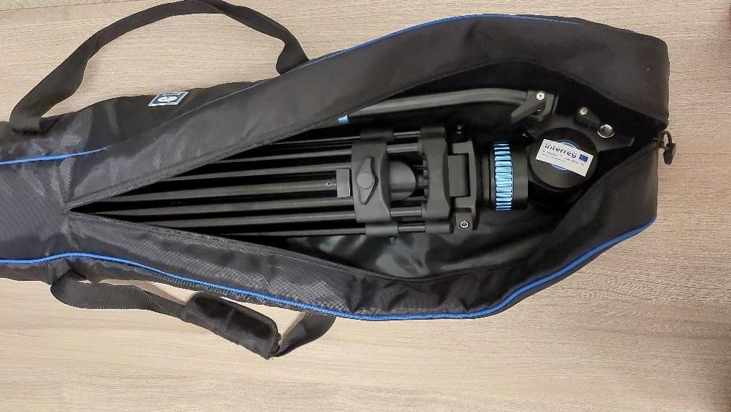

Financial complexity of the project
The price of the basic equipment reached the amount of 100 000 CZK. All equipment was provided to our school free of charge in the form of a loan within the DigiMe project.
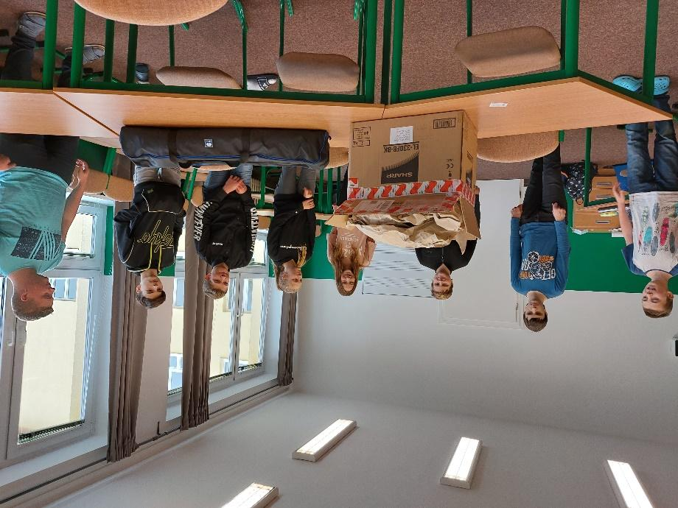

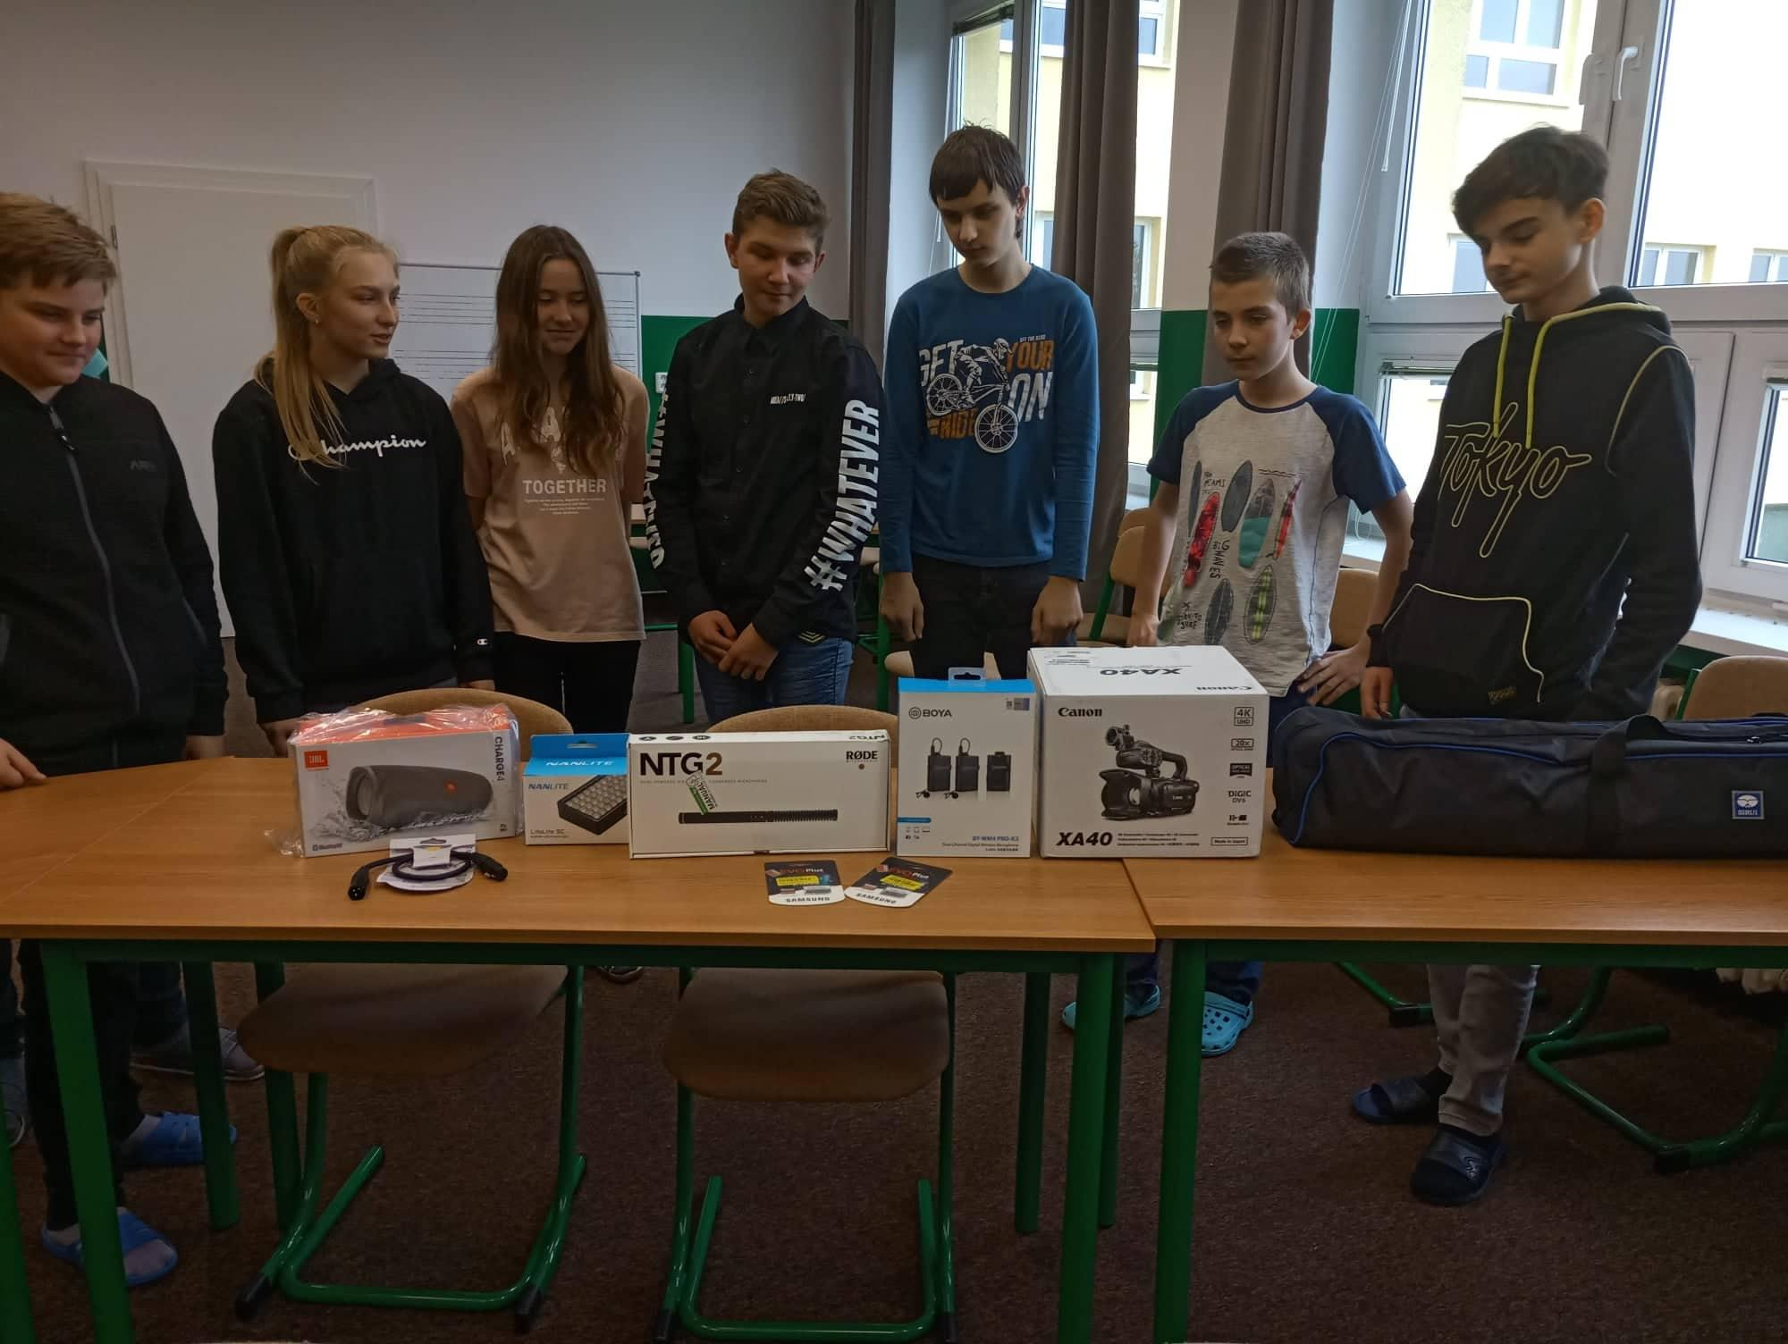

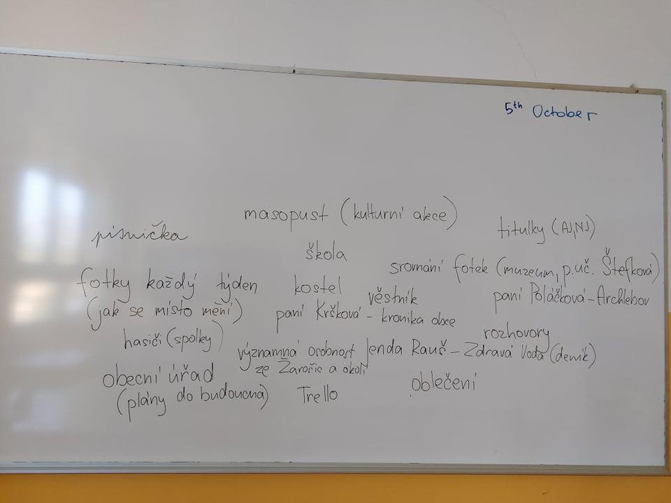
Movie script
We used the time we were waiting for the delivery of the equipment to prepare the script. First, the students got acquainted with how the script of the film should look, and what the preparation team should read from it. What followed was a passionate debate about what we would put in the film, what we want to show to the surrounding world as part of the promotion of the village.

What followed was a rather painful procedure of choosing what would actually fit into the script and what we would have to forget. With the help of very lively communication in MS Teams, which often resembled a battlefield, we finally selected the most important things from the life of the school and the village.

Getting to know the technique

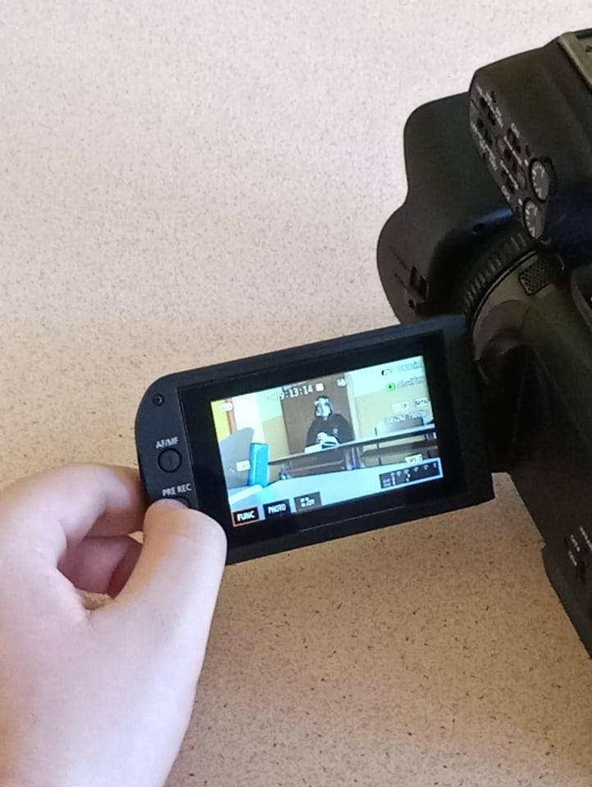
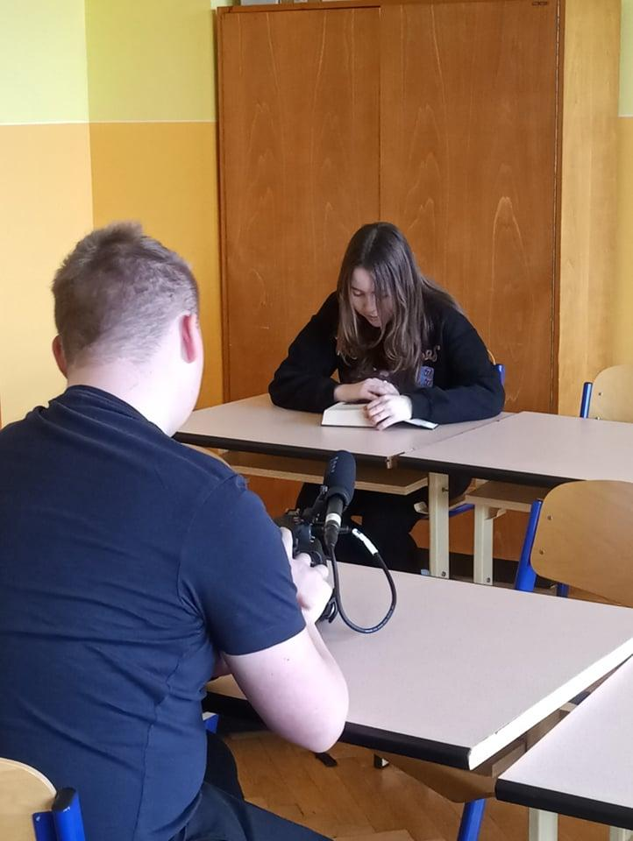
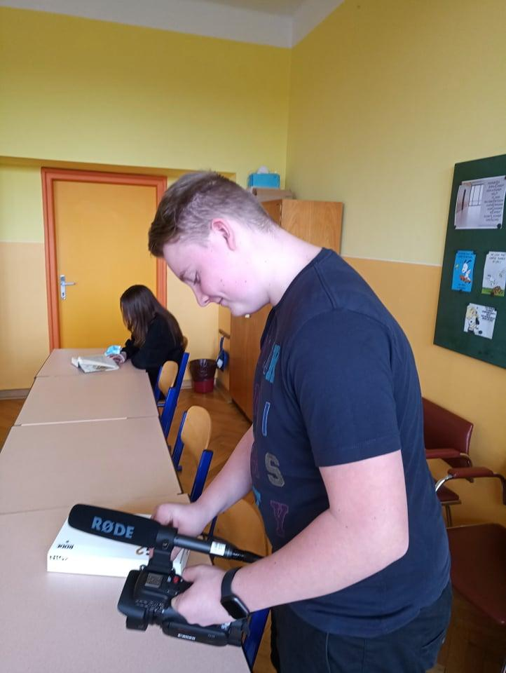
After receiving the necessary equipment, we could finally get to work. First we were figuring out how to attach the microphone to the camera. Using the tests we read, we found out from what distance and from what angle the filming itself needs to be done so that the voice can be heard well and clearly.

First flight tests
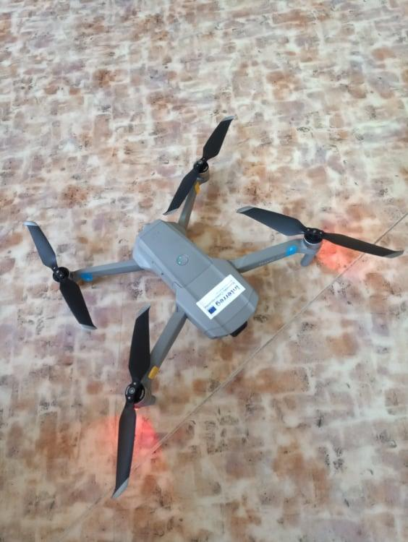
Unfortunately, the drone did not arrive at our school until February. This greatly reduced the space for rehearsing and filming itself. Due to the fear that the students' first attempt to take off and control the drone would not be the last one with the drone flying away from us irretrievably. We performed the first flight experiments in a closed room of the school classroom. Only later, when there was hope that we would release the drone and that it would return to us again after completing the task, we ventured out into the exterior of the school.

Exteriors
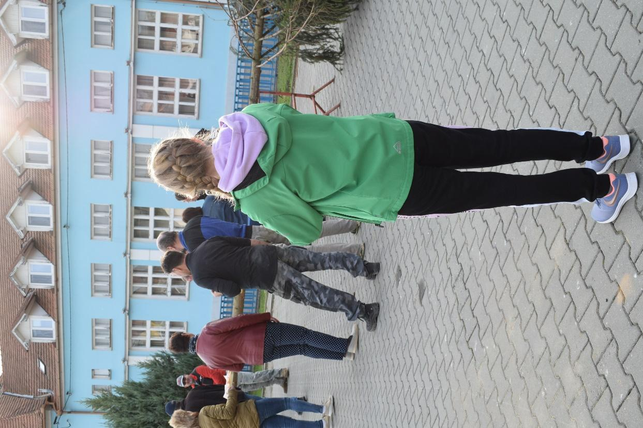
After the theoretical preparations, we were finally able to go out.
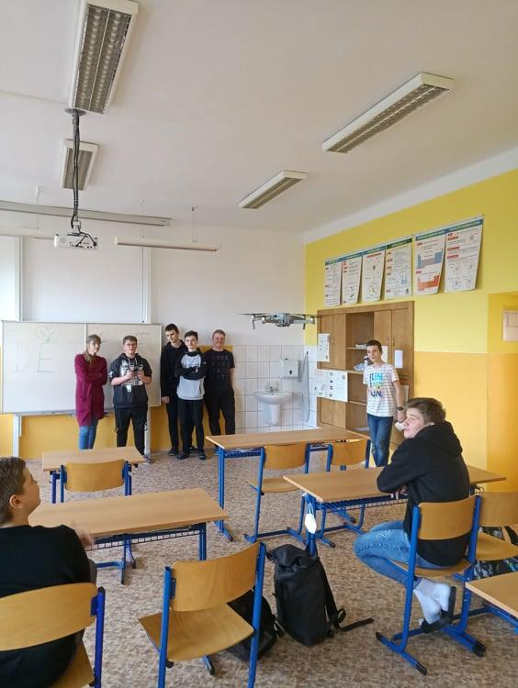

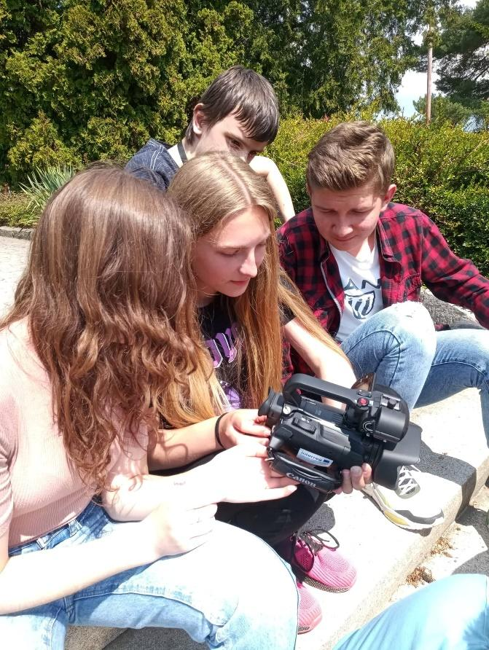
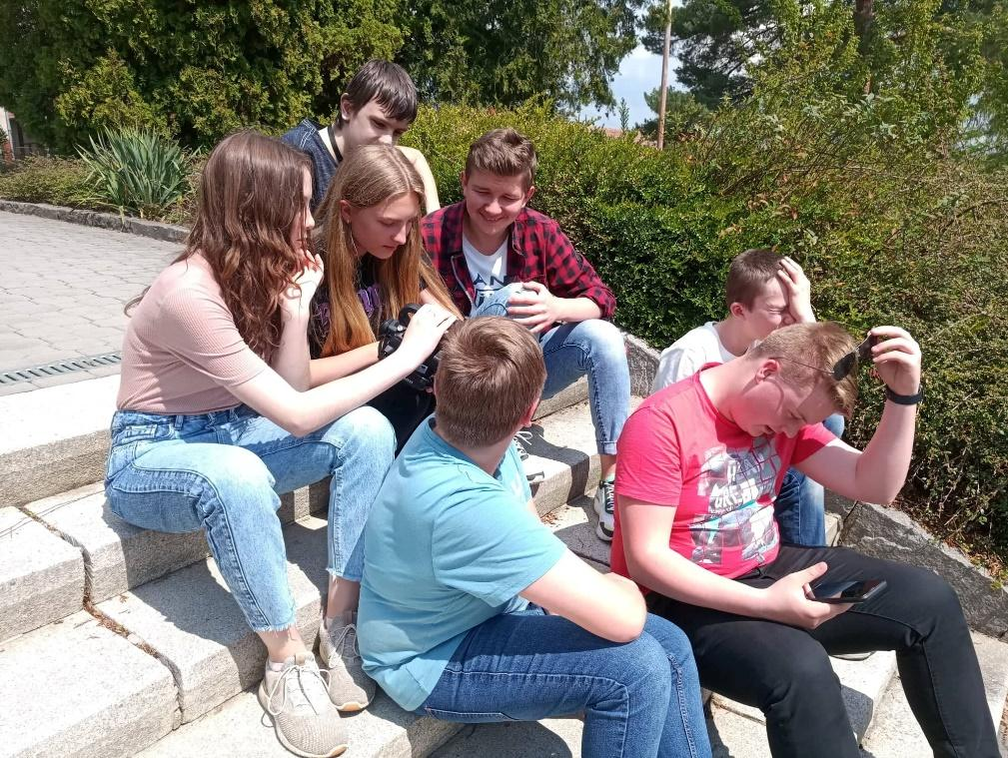

Video editing
When editing the video, we used the previous experience of one of our students with video editing. Even though he didn't have control over the program we got for the project, he was able to get the computer to do exactly what we needed it to do in a very short time.

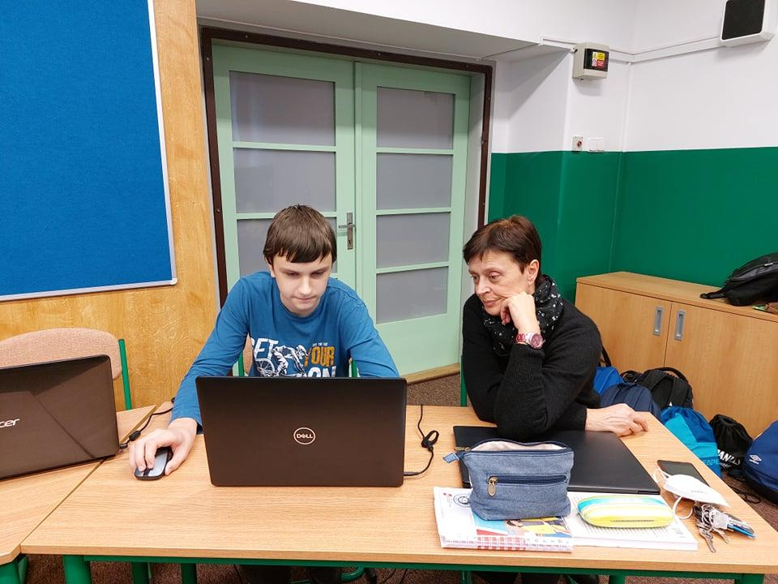

Conclusion
Throughout the project, we were accompanied by a lot of different foreseen and unforeseen situations.
However, there were several factors that slowed down the filming process:
- bad weather. Why does it have to be raining or windy right at the time of our meeting that everyone is afraid to just look at the drone, let alone try to get it in the air?
- limited opportunities for the entire team to meet, as we are a drop-in school. Every member of our team lived in another village. We did have a lunch break between morning and afternoon classes for our meetings, but that time was very short and we were soon pressed for time. Adding to that the various school activities that took our team members away from us for the week, the team began to talk very loudly about further cuts in the script. Saturdays and Sundays were also put on the agenda as the only possible days when we can actually do some work.
- COVID 19. One of the issues that greatly affected the course of the entire school year. Many of the regular events that take place in the school or village, which were intended for the film, were suddenly canceled due to the ban of gatherings and holding mass affairs. We thus didn't have the school ball which was held after the restrictions in May (that is, almost after the end of the project) and others.
As part of the entire team collaboration, we had to constantly improvise.
However, despite all the problems and partial failures, we really enjoyed our joint cooperation. We experienced a lot of humorous situations and will remember them for a long time. We take away from the project the decision that, despite all the hardships of the world, it was worth it and that in the years to come we will also try what the audio-visual technology entrusted to us can do. For example, a world-renowned director or cameraman will grow up in the Žarošice school.

